Jahnvi Pael

2024-01-23

library(dplyr)

##   
## Attaching package: 'dplyr'

## The following objects are masked from 'package:stats':  
##   
## filter, lag

## The following objects are masked from 'package:base':  
##   
## intersect, setdiff, setequal, union

library(ggplot2)  
library(caret)

## Loading required package: lattice

# Load train and test datasets  
train_data <- read.csv("adm_train.csv")  
test_data <- read.csv("adm_test.csv")

# Explore the data  
str(train_data)

## 'data.frame': 249 obs. of 9 variables:  
## $ Serial.No. : int 1 2 3 4 5 6 7 8 9 10 ...  
## $ GRE.Score : int 337 324 316 322 314 330 321 308 302 323 ...  
## $ TOEFL.Score : int 118 107 104 110 103 115 109 101 102 108 ...  
## $ University.Rating: int 4 4 3 3 2 5 3 2 1 3 ...  
## $ SOP : num 4.5 4 3 3.5 2 4.5 3 3 2 3.5 ...  
## $ LOR : num 4.5 4.5 3.5 2.5 3 3 4 4 1.5 3 ...  
## $ CGPA : num 9.65 8.87 8 8.67 8.21 9.34 8.2 7.9 8 8.6 ...  
## $ Research : int 1 1 1 1 0 1 1 0 0 0 ...  
## $ Chance.of.Admit : num 0.92 0.76 0.72 0.8 0.65 0.9 0.75 0.68 0.5 0.45 ...

summary(train_data)

## Serial.No. GRE.Score TOEFL.Score University.Rating SOP   
## Min. : 1 Min. :290.0 Min. : 93.0 Min. :1.000 Min. :1.00   
## 1st Qu.: 63 1st Qu.:310.0 1st Qu.:104.0 1st Qu.:2.000 1st Qu.:3.00   
## Median :125 Median :318.0 Median :108.0 Median :3.000 Median :3.50   
## Mean :125 Mean :317.6 Mean :108.3 Mean :3.249 Mean :3.54   
## 3rd Qu.:187 3rd Qu.:326.0 3rd Qu.:112.0 3rd Qu.:4.000 3rd Qu.:4.50   
## Max. :249 Max. :340.0 Max. :120.0 Max. :5.000 Max. :5.00   
## LOR CGPA Research Chance.of.Admit   
## Min. :1.500 Min. :6.800 Min. :0.0000 Min. :0.3400   
## 1st Qu.:3.000 1st Qu.:8.200 1st Qu.:0.0000 1st Qu.:0.6400   
## Median :3.500 Median :8.640 Median :1.0000 Median :0.7300   
## Mean :3.546 Mean :8.641 Mean :0.5582 Mean :0.7284   
## 3rd Qu.:4.000 3rd Qu.:9.100 3rd Qu.:1.0000 3rd Qu.:0.8500   
## Max. :5.000 Max. :9.920 Max. :1.0000 Max. :0.9700

# Renamed columns  
colnames(train_data) <- c("Serial No", "GRE", "TOEFL", "University Rating", "SOP", "LOR", "CGPA", "Research", "Chance of Admit")  
colnames(test_data) <- c("Serial No", "GRE", "TOEFL", "University Rating", "SOP", "LOR", "CGPA", "Research", "Chance of Admit")

any_missing_train <- any(is.na(train_data)) # there are no missing values in the entire train_data data set.  
any_missing_test <- any(is.na(test_data)) # there are no missing values in the entire test_data data set.

# Detecting Outliers  
# Boxplot for Score  
boxplot(train_data$GRE, main = "Boxplot of GRE")

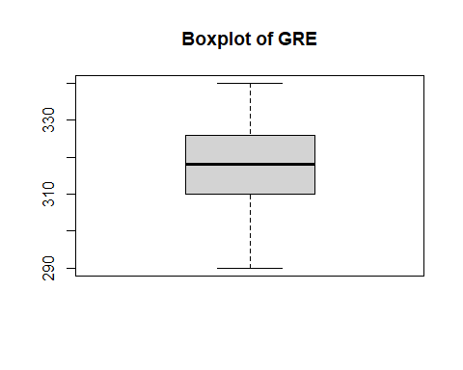

boxplot(train_data$TOEFL, main = "Boxplot of TOEFL")

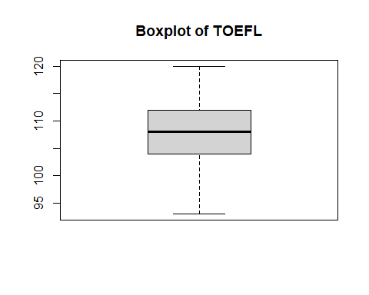

boxplot(train_data$CGPA, main = "Boxplot of CGPA")

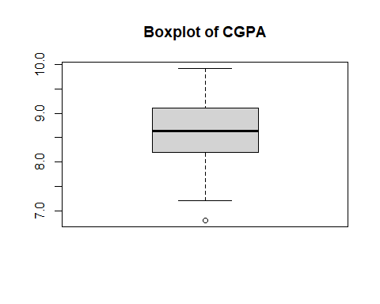

# Identifying outliers using z-score  
z_scores <- scale(train_data$CGPA)  
outliersCGPA <- which(abs(z_scores) > 3) # outlier detected at 59

# Imputed outlier with the median of CGPA directly in the same column  
train_data$CGPA[abs(z_scores) > 3] <- median(train_data$CGPA, na.rm = TRUE)

#Checking Data Distribution  
# Histogram   
hist(train_data$CGPA, main = "Histogram of CGPA", col = "lightblue")

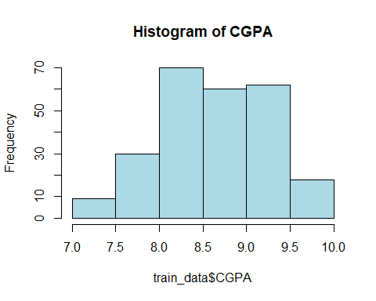

hist(train_data$GRE, main = "Histogram of GRE", col = "blue")

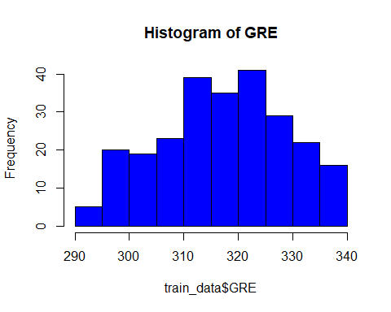

hist(train_data$TOEFL, main = "Histogram of TOEFL", col = "green") # doesn't feel like data is highly skewed.

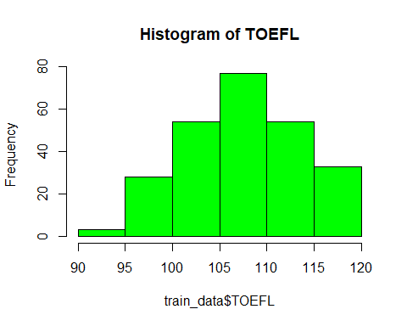

# Visualizing Correlations  
# Correlation matrix  
train_correlation_matrix <- cor(train_data[, c("GRE", "TOEFL", "CGPA", "Research", "Chance of Admit")])

# Create a heatmap using corrplot  
library(corrplot)

## corrplot 0.92 loaded

corrplot(train_correlation_matrix, method = "number", col = colorRampPalette(c("white", "blue", "red"))(100), number.cex = 0.7) # This approach can be helpful when the color differences are not very pronounced

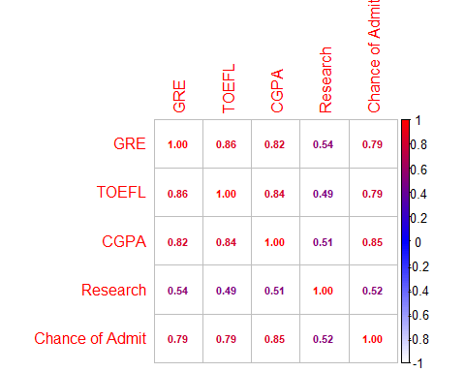

# Multiple correlations using the psych package  
library(psych)

##   
## Attaching package: 'psych'

## The following objects are masked from 'package:ggplot2':  
##   
## %+%, alpha

pairs.panels(train_data[, c("GRE", "TOEFL", "CGPA")])

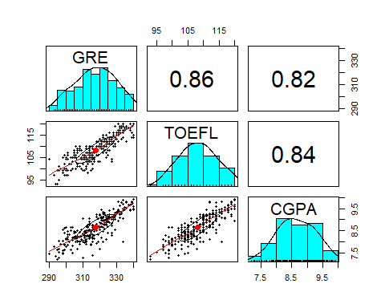

# Scatter plot of GRE vs. CGPA  
library(ggplot2)  
ggplot(train_data, aes(x = GRE, y = CGPA, color = `Chance of Admit`)) +  
 geom_point() +  
 geom_smooth(method = "lm", se = FALSE, color = "blue") +  
 labs(title = "Scatter Plot of GRE vs. CGPA") +  
 scale_color_gradient(low = "blue", high = "red")

## `geom_smooth()` using formula = 'y ~ x'

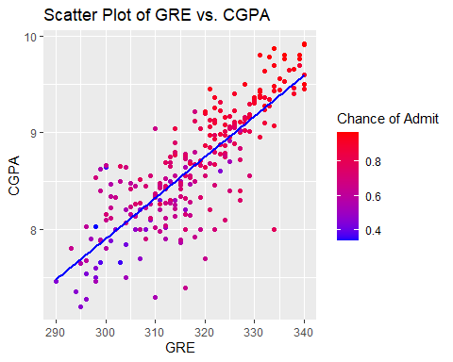

# Scatter Plot of TOEFL vs. CGPA  
ggplot(train_data, aes(x = TOEFL, y = CGPA, color = `Chance of Admit`)) +  
 geom_point() +  
 geom_smooth(method = "lm", se = FALSE, color = "blue") +  
 labs(title = "Scatter Plot of TOEFL vs. CGPA") +  
 scale_color_gradient(low = "blue", high = "red")

## `geom_smooth()` using formula = 'y ~ x'

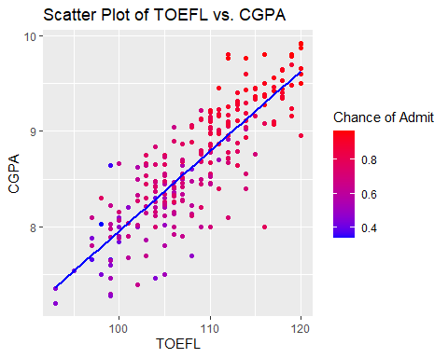

# Scatter Plot of GRE vs. TOEFL  
ggplot(train_data, aes(x = GRE, y = TOEFL, color = `Chance of Admit`)) +  
 geom_point() +  
 geom_smooth(method = "lm", se = FALSE, color = "blue") +  
 labs(title = "Scatter Plot of GRE vs. TOEFL") +  
 scale_color_gradient(low = "blue", high = "red")

## `geom_smooth()` using formula = 'y ~ x'

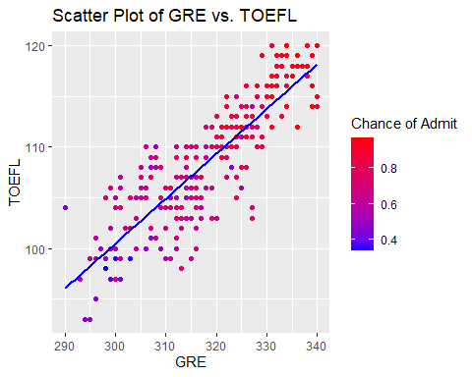

# Linear regression model  
model <- lm(`Chance of Admit` ~ GRE + TOEFL + CGPA + Research, data = train_data)

# Model evaluation  
predictions <- predict(model, newdata = test_data)  
actual_outcomes <- test_data$`Chance of Admit`  
mse <- mean((actual_outcomes - predictions)^2)

# Saved predictions to a CSV file  
predictions_df <- data.frame(Chance_of_Admit_Predicted = predictions)  
write.csv(predictions_df, "predicted_results.csv", row.names = FALSE)